Vietnamese Salad Rolls
For 2-3

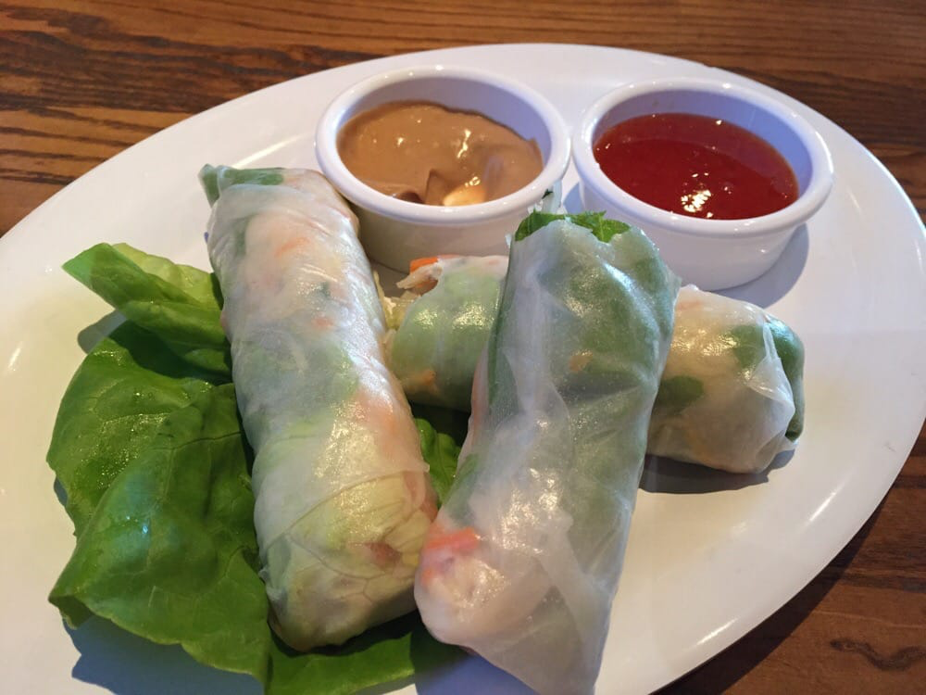
Ingredients
Rice vermicelli
Rice paper rolls
1 Carrot, julienne
1/3 Cucumber, julienne
Red cabbage, thinly sliced
3 leaves of Lettuce, thinly sliced
Cilantro
45ml Sweet chilli sauce

Method
- Bring a medium saucepan of water to boil. Remove from heat. Place rice vermicelli in boiling water, remove from heat, and let soak 3 to 5 minutes, until soft. Drain, and rinse with cold water.
- Julienne carrots and cucumber (cut into thin slices). Wash and dry lettuce. Cut lettuce into bite size pieces. Arrange on a plate.
- Fill medium sized pan with 1 inch of water. Place rice paper in water for 5 seconds then remove rice paper. Drain excess water.
- Place all ingredients on rice paper and wrap tightly.
Peanut Sauce
- 60ml peanut butter natural, unsweetened
- 15ml low sodium soy sauce
- 7.5ml rice vinegar
- 15ml brown sugar
- 5ml fresh lime juice
- 1 garlic clove, miced
- 5ml ginger root, minced
- 15-30ml warm water

Instructions
- Combine all ingredients except water. Whisk to fully combine.
- Add water, 5ml at a time, until desired consistency is reached.

