Tofu Stir-Fry
Ingredients
¼ package of sliced firm tofu
60ml soy sauce
10ml brown sugar
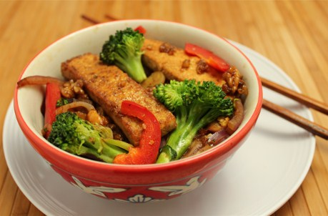
5ml minced garlic
5ml grated ginger root

15ml water
10ml oil
5ml cornstarch

onion
roughly chopped vegetables

125ml cooked rice
chopped fresh cilantro

Method Day 1:
- Slice tofu into square inch pieces. Fry in a medium fry pan with 5ml of oil until brown.
- In a small bowl, mix ginger, soy sauce and brown sugar. Cover (label with your names and block) and refrigerate until next class.

Method Day 2:
- In a small bowl, whisk together cornstarch and water. Set aside.
- In a wok, heat oil over medium-high heat. Add onions and stir fry for 3 minutes. Stir in vegetables and stir-fry for 3 to 4 minutes or until vegetables are tender-crisp.
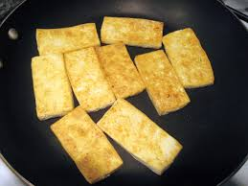
- Add tofu mixture and cornstarch mixture. Stir for 3 to 4 minutes or until thickened and heated through.
- Serve over rice. Sprinkle with cilantro.

