Food Studies 9
Tofu Stir-Fry
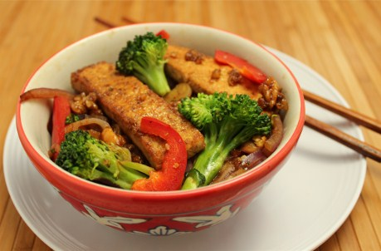
Day 1:
Ingredients Tofu Marinade:
¼ package of sliced firm tofu, cubed
30ml soy sauce
5ml brown sugar
1 clove minced garlic
5ml minced ginger root
Method:
- Slice tofu into square inch pieces.
- In a small bowl, mix tofu, ginger, soy sauce and brown sugar. Cover (label with your names and block) and refrigerate until next class.

Day 2:

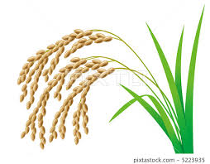
How to Cook Rice
Serves 4/5 – Make 1 per group
300ml rice
600ml cold water
2ml salt

- Measure all three ingredients into a medium pot that has a tight fitting lid.
- Put lid on pot and turn heat to high.
- When water boils, lift the lid and give the rice a quick stir with a fork.
- Replace the lid. Lower heat to the lowest setting on the stove.
- Set timer for 20 minutes. DO NOT PEEK DURING THIS TIME!
- After 20 minutes, you should see ‘fish eyes’ on the surface of the rice and the kernels should have absorbed all the water.
- Lightly, with a fork, lift the rice a few times to fluff it up.

Teriyaki Sauce:
35 ml brown sugar- packed
8 ml sesame oil
35 ml rice vinegar
8 ml cornstarch
35 ml water
1 clove minced garlic
35 ml soy sauce
5 ml minced ginger root

To Fry Tofu:
15ml vegetable oil
5ml sesame oil
5ml rice vinegar
5ml soy sauce
Stir Fry:
5ml vegetable oil
Onion, diced
Carrot, diced
Broccoli, diced
Pepper, diced
chopped fresh cilantro

Method:
- Add all teriyaki sauce ingredients to leftover tofu marinade. Whisk together all the sauce ingredients until smooth. Set aside.
- In a small pan, add the vegetable oil, sesame oil, rice vinegar, and soy sauce from the “to fry tofu”. Heat on medium/high heat. Add tofu. Stir fry until golden brown and crisp.
- While tofu is cooking, chop up all vegetables.
- Once tofu is cooked, set aside.
- In a wok heat 5ml vegetable oil on medium heat. Add onions, cook until translucent. Add all other vegetables. Cook until tender crisp.
- Add the sauce and cook 2 minutes or until thickened and bubbly.
- Add tofu back to stir fry. Serve over the rice. Garnish with chopped cilantro.
