Sweet Potato and Lemongrass Soup
Serves 2-3

Ingredients
½ of a large sweet potato, peeled and medium diced
1 stalk lemongrass, outer layers removed
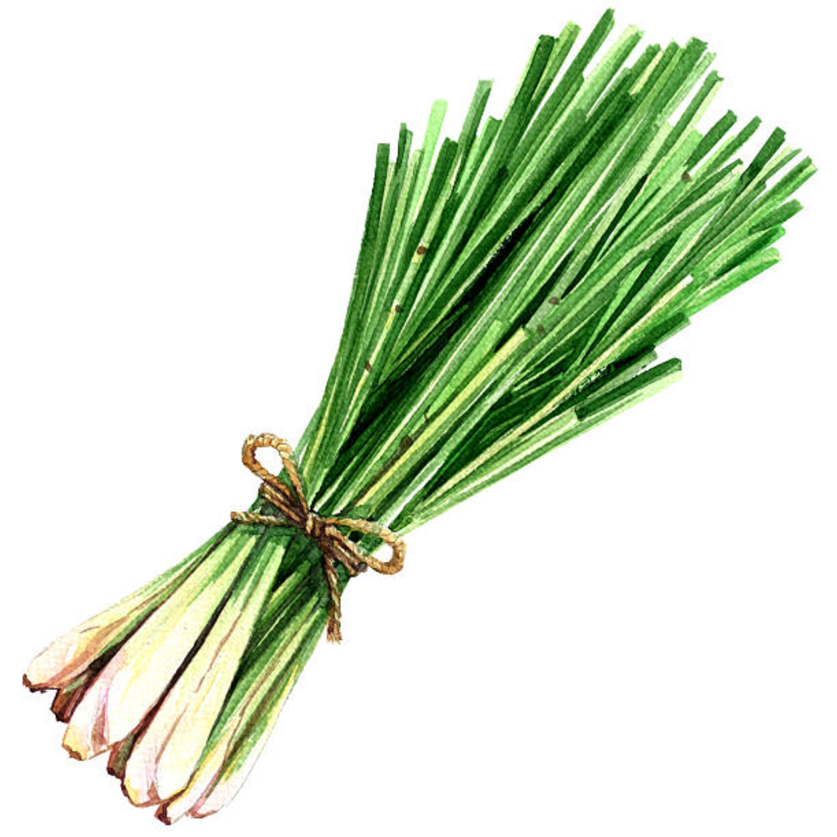
7.5 ml olive oil
¼ white onion, minced
1 clove garlic minced
¼ of a jalapeno pepper
5 ml ginger, peeled and minced
100 ml coconut milk
5ml lime juice
2 ml salt
.5 ml cayenne pepper (optional)

Method
- In a large saucepan, combine sweet potatoes and lemongrass with enough cold water to cover; bring to a boil. Reduce heat to medium; simmer until potatoes are tender, about 20 mins. Remove lemongrass. Drain potatoes; reserve 175 ml of cooking liquid.
- Meanwhile, in a medium skillet over medium heat, heat up olive oil. Add onion; cook stirring occasionally until soft.
- Add garlic and cook for about a minute. Add jalapeno and ginger and cook for about 2 minutes
- In a blender, process potatoes, onion mixture, coconut milk, and half of the cooking liquid until smooth.
- Return soup to saucepan and stir in the remainder of the cooking liquid, bring to simmer over medium heat.
- Stir in lime juice, salt and cayenne pepper.
- Serve and enjoy !

