Sushi: California Roll
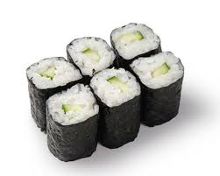
Day 1 Ingredients:
250ml short grain rice
300ml water
45ml rice vinegar
15ml sugar
2ml salt

Method:
- Combine rice and water in a medium pot. Bring water to a boil.
- Turn the heat to low, cover and steam for 20 minutes. Place cooked rice in a large bowl to cool.
- Combine vinegar and sugar in liquid measures. Stir to dissolve sugar. Pour slowly over rice, stirring rice gently. Do not over mix rice.
- Put rice in an 8 by 8 pan (tin or glass). Let cool completely, cover with plastic wrap, label and refrigerate.
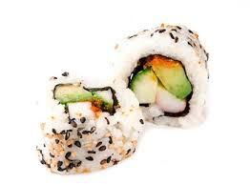
Day 2 Ingredients:
4 sheets of nori (seaweed)
Cucumber, thinly sliced
Avocado
Immitation crab
Japanese mayo
Ginger, wasabi and soy sauce

Method:
- Place plastic wrap over bamboo rolling mat. Place nori on sushi mat, shiny side down.
- Slightly spread rice over all but one inch along top end, it should be about two rice grains thick.
- Place fillings about 1/3 up from the lower edge. Squeeze one thin strip of Japanese mayo along fillings. Roll firmly from bottom, pulling mat out from being rolled inside.
- Slice and serve with pickled ginger, wasabi and soya sauce.

