Spaghetti and Italian Meatballs
Serves 4-5
Ingredients
Spaghetti for 4-5 5ml Italian herd seasoning
1lb (500ml) ground beef Fresh parsley
40ml bread crumbs 1 clove garlic
60ml milk 2ml salt
15ml olive oil 2ml pepper
½ diced onion 2ml red pepper flakes
1egg 15ml grated parmesan cheese
500ml tomato sauce

Method:
- Preheat oven to 425 F.
- Bring a large pot of salted water to a boil.
- Add spaghetti and cook for 8-9 minutes, stirring occasionally until pasta is al dente, drain.
- Cover a baking sheet with foil.
- Soak bread crumbs in milk in a small bowl for 10 minutes
- Heat olive oil in a skillet over medium heat. Cook and stir onions until translucent.
- In a large bowl, mix ground beef, bread crumb mixture, egg, parsley, garlic, salt, pepper, red pepper flakes, Italian seasoning and parmesan cheese using a rubber spatula.
- Using wet/clean hands, form meat mixture into balls about 1 ½ inches in diameter. Arrange onto prepared baking sheet.
- Bake in the preheated oven until browned and cooked through. 15-20 minutes.
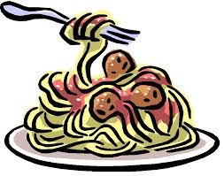
- In a skillet, heat tomato sauce. Add meatballs and cook further. 5-10 minutes.

