Foods 10

CHEESE FILLED HOMEMADE RAVIOLI
In 2/3s

Ingredients:
Dough: Cheese Filling:
325 mL Flour 125 mL Mozzarella Cheese, shredded
2 Eggs 50 mL Parmesan Cheese
30 mL Water 125 mL Ricotta Cheese
5 mL Salt 1 Egg (add on day 2)
5 mL Oil ¼ Package, frozen spinach, drained

Method:
Day 1:
Dough:
- In a large mixing bowl, sift flour and salt together.
- Make a “well” in the flour. Break eggs into the ”well”. Add water and oil. Beat the eggs with a fork. Gently work some flour from the side of the well into beaten eggs.
- Stir until mixture forms a ball.
- Knead vigorously until dough is smooth and elastic.
- Wrap dough tightly in plastic wrap. Put name on it and put it on the demo table.
Cheese Filling:
- Combine first four (4) ingredients into a bowl.
- With your spinach, place it in paper towel, and squeeze out excess liquid, this step may need to be repeated. This is to ensure all excess liquid is removed (else your ravioli will be soggy).
- Add spinach to other ingredients (except egg), mix well. Place in a labeled container and put on the demo table.
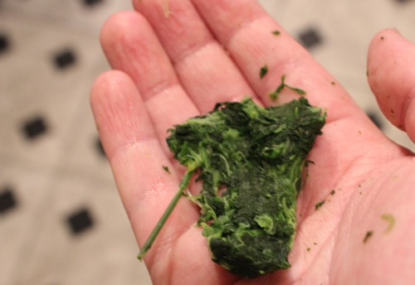
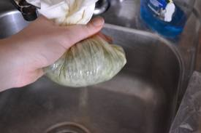

Homemade Ravioli Day 2

Make the Ravioli:
  - Set up pasta machine on unit table.
  - Roll dough out on pasta machine. It shouldn’t be any thinner than the second last setting. Trim ends to be square.
  - Place about 5 mL filling at 5 cm intervals along one edge of pasta strip.
  - Brush along edge of pasta with egg-water mixture (1/2 Egg and 15 mL Water), and then lift pasta over filling and seal edges of pasta around fillings, pressing well to close completely. It is important to remove excess air
  - Using your dough scraper, cut between the mounds of filling. Make sure your ravioli are sealed; use a fork to press all edges.

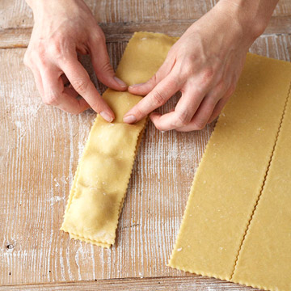

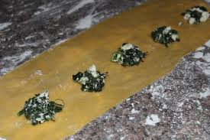
Cooking Instructions:
- In a large pot, bring to boil a large quantity of salted water. Once water is boiling, add pasta, uncovered and cook up to 6 minutes (pasta is cooked when it floats to the top of the water).
- Remove pasta with a slotted spoon into colander. Drain well.
- Place a small amount of sauce on plate; add pasta and spoon on more sauce.
- Serve warm.

Tomato Sauce
Ingredients:
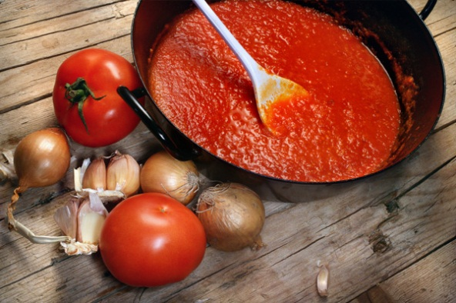
10 mL Oil
25 mL Onion, finely chopped
1 clove Garlic, minced
250 mL Tomato sauce
f.g. Oregano and basil
45 mL Parmesan cheese
10 mL Parsley, chopped
Method:
- Heat small pot on medium heat and sauté onion and garlic for until soft and clear.
- Add the tomato sauce and seasonings. Bring mixture to a low boil then simmer for ~10 minutes to incorporate the flavours.
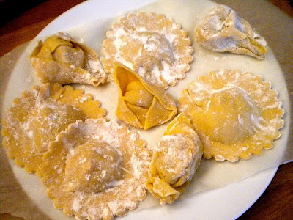
- Place a spoonful of sauce on plate (use back of spoon to spread it out on plate). Place cooked ravioli on the platter and top with remaining sauce. Sprinkle with Parmesan cheese and parsley. Serve immediately.

