Raisin Scones
Cooking Principle-Biscuit Method
Groups of 2/3 Students

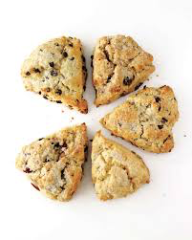
275ml flour
15ml sugar
6ml baking powder
1ml baking soda
1ml salt
60ml cold margarine
60ml raisins
125ml buttermilk

Method:

- Pre-heat oven to 425F
- In a large bowl, measure flour, sugar, baking powder, baking soda and salt. Mix together, using a whisk.
- With a pasty cutter, cut in the margarine into the flour mixture until mixture looks coarse and crumbly.
- Add raisins.
- Pour buttermilk over dry ingredients. With a fork, toss together until soft and slightly sticky.
- Dust counter and your hands lightly with flour. Place dough on counter and lightly knead 10-15 times.
- Pat dough into a circle about 1.5cm thick.
- Cut scones into 8 wedges.
- Bake until done. About 12-15 minutes. Tops are golden brown.
