Mini Pumpkin Pie

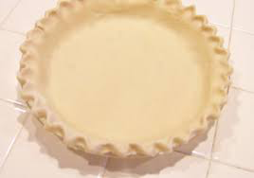
Pastry Ingredients:
250ml flour
2ml salt
50ml shortening
50ml margarine
½ egg
7ml vinegar
15ml cold water

Day 1 Method:

- Combine flour and salt in mixing bowl.
- Cut in shortening and margarine into flour with pastry blender until mixture is uniform and resembles coarse crumbs.
- Stir the water, egg and lemon juice together in a small bowl. In a circular motion pour contents onto flour mixture.
- Stir with a fork until the mixture is moistened. Make sure not to over mix to prevent making a tough crust.
- Place dough in plastic bag, with name on it and put into fridge.

Day 2 Ingredients:
250ml Pumpkin puree
2ml salt
125ml half and half
90ml brown sugar
1 egg
1 egg yolk
1ml nutmeg
1ml cinnamon
.5ml cloves

Day 2 Method:
- Preheat the oven to 400F
- Roll out the pastry until 1cm thick. Using a small bowl, cut out pastry and place into muffin tins.
- In a medium sized bowl, whisk together brown sugar, spices and salt until well combined. Mix in the pumpkin puree, eggs and half and half until fully combined.
- Spoon the pumpkin pie filling evenly between the pie. Filling to about ¾ full.
- Bake for approx 18 minutes or until the tops of the mini pumpkin pies look set.

