Potstickers

Ingredients:

250mL Napa cabbage, finely minced
15mL Sesame oil
7mL Rice vinegar
200g Lean ground pork
Pre-made dumpling skins

7mL Gingerroot, minced
3mL Garlic, mined
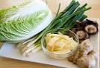
15mL Soy sauce
5mL Cornstarch

Day 1:
Method:
- Finely mince the cabbage. Add the ground meat, and all the seasonings.
- Stir meat mixture thoroughly with a wooden spoon, if the mixture is not sticking together, add another 2mL cornstarch.
- Place a heaping 5mL of filling in the center of each dumpling skin. Spread a little water along the inside edge of the skin. Form pleats with your thumb (be sure to push out all the air), pinch to seal. See diagram.
- Place the sealed dumplings onto a baking sheet with parchment paper.
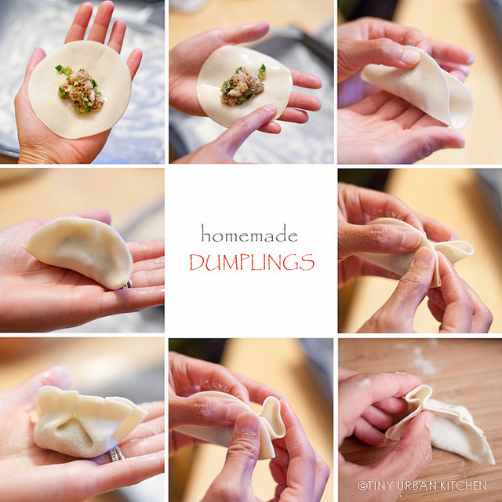

Day 2:
Ingredients:
25 mL Oil 50 mL hot water

To cook dumplings:
- Preheat a large frying pan on medium/high heat.
- Add 25mL of oil to pan and heat until very hot. Arrange the dumplings, pleated side up, to line the bottom of the pan.
- Fry the dumplings until their bottoms are golden brown.
- Add 50mL hot water to the pan and cover. Reduce heat to low and cook for about 5 minutes. Uncover and increase heat to medium high. Continue frying until the bottoms are crisp (NOT burnt!) (~2 minutes). If you wish to crisp all sides, use tongs or a pair of chopsticks to turn dumplings as it is frying the second time.

Dipping Sauce Ingredients:
30ml soy sauce
15ml rice vinegar
10ml sesame oil
A pinch of crushed dried red pepper flakes

Method:
- Measure and mix all ingredients into a custard cup.

