**PEROGIES**

This recipe serves 2-3 people; maximum 2 recipes per unit.

# DAY 1: Dough

|  |  |
| --- | --- |
| 125 mL | Water |
| ½ | Egg |
| 1 mL | Salt |
| 8 mL | Vegetable Oil |

1. Mix the above ingredients together with a wooden spoon.
2. Mix in just enough flour to make soft dough (about 325-350 mL).
3. Knead 5 minutes, until the surface is smooth and elastic. Dough must be able to stretch.
4. Shape dough into a ball and place dough inside a lightly oiled, labeled plastic bag.

# DAY 1: Potato Filling

|  |  |
| --- | --- |
| 1 | Large potato |
| ¼ | Medium onion, peeled & chopped |
| 35 g | Cheddar cheese, grated (optional) |
| 10 mL | Margarine (enough to coat bottom of frying pan) |
|  | Salt & pepper to taste |

1. Fill a medium saucepan about ⅔ full of cold water. Cover and bring to a boil over high heat. Meanwhile, peel and dice potatoes into 1 cm cubes. Once water in saucepan has boiled, carefully add diced potatoes to the water and return to a boil. **DO** NOT cover the pot after potatoes have been added to avoid boil-over. Reduce heat so the water remains at a simmer. Cook 10 minutes or until potatoes are soft when pierced with a fork.
2. Prepare onions. While potatoes are boiling, heat margarine in frying pan. Add onions and sauté just until transparent (clear).
3. When potatoes are cooked, drain them in a colander and return them to the pot. Mash the potatoes until they are no longer chunky. Mix in onions, cheese (optional), and salt & pepper to taste.
4. Put filling in a small bowl or covered container, label, and place in refrigerator.

# DAY 2: PREPARE PEROGIES

1. Fill the large saucepan ⅔ full of hot water. Put 10 mL of oil in the water. Cover, and bring to a boil over high heat. If water boils too soon, turn heat down and keep water hot until you’re almost ready, then bring it back to a boil.
2. Roll out dough on a dry surface until very thin. If the dough is not rolled thin enough, the perogy will be doughy and will have little filling.

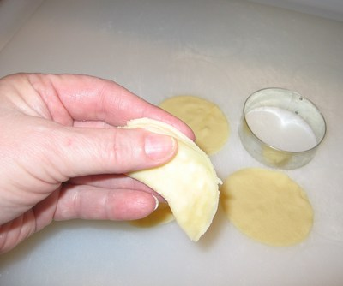

1. Cut into circles the size of a custard cup (run a paring knife gently around the edge of an inverted custard cup) or use a large biscuit cutter to cut out rounds.
2. Place a small amount of filling on one side of the centre of the circle, leaving space around the edge for sealing the circle together.
3. Moisten the edges of the circle by brushing on water. Fold in half and press edges together. Try to avoid trapping air inside. Press edges with a fork or with your fingers to seal.
4. Put completed perogies on a towel-lined cookie sheet. Cover with a towel.

7. **Cook the perogies by:**

1. **Boiling:** Gently place perogies in boiling water and cook until they float. If desired, melt about 25 mL of margarine in a frying pan (as described below) and fry 125 mL of onion, cut into strips to serve with the perogies. Perogies may also be lightly browned in the frying pan after boiling, if desired.
2. **Frying:** Melt some margarine (about 25 mL) in a preheated electric frying pan (350°F) or in a frying pan on the stovetop (#3-4). If desired, add 125 mL of onion, cut into strips (or cook onion separately from perogies). Add perogies and fry until golden brown on both sides.
3. Serve perogies with onion and 25 mL of sour cream per person, if desired.

