Chicken Pad Thai (for 4)
Ingredients
250g flat rice noodles
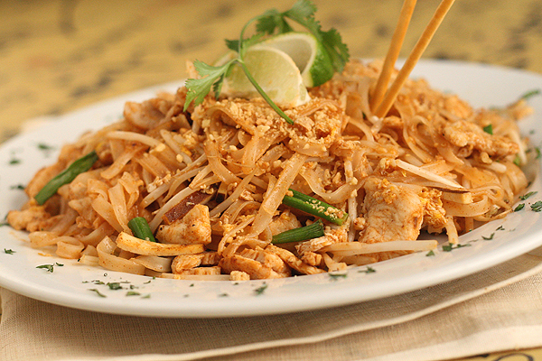
60g chicken breast
50 mL tofu
1 carrot
30 mL bean sprouts
30 mL lime juice
30 mL soy sauce
20 mL fresh grated ginger
2 mL chilli sauce
15 mL oil
1 garlic clove, minced
2 green onions
15 mL cilantro
15 mL chopped toasted peanuts
¼ lime for garnish

Method:
- Put a large pot of water on to boil. Once it comes to a boil, turn off the heat, add noodles and let them soak until tender (about 5 minutes). Drain noodles in a colander, rinse with cold water and set aside.
- Cut chicken into thin strips and place win a bowl.
- Trim the bean sprouts if needed. Julienne the carrots. Put into a small bowl.
- In a separate bowl, stir together lime juice, soy sauce, ginger, and chilli sauce.
- Drain the tofu and cut into ½ inch cubes.
- Heat 15 mL oil in frying pan. Add the tofu and sauté until golden, stirring often. Set aside
- In a wok, heat over high heat. Stir fry the garlic for 10 seconds and then add the chicken.
- Stir fry until chicken is no longer pink. Add the carrots and stir fry for 2 more minutes. Add the noodles and half of the sauce. Stir. Cook until the noodles are heated through.
- Stir in bean sprouts, green onion, tofu, and remaining sauce. Cook for one minute.
- Put the food on a dish and garnish with fresh cilantro, peanuts and lime.

