Foods 9
One-Dish Rotini Pasta
Ingredients
375ml rotini pasta
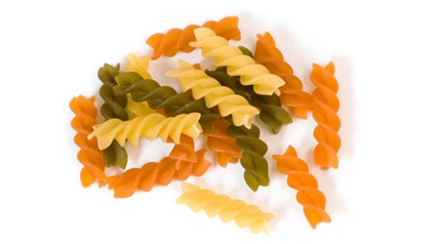
180ml various vegetables, cut into bite size pieces
15ml margarine
¼ onion, small diced
1 garlic clove, minced
125ml cheddar cheese, grated
60ml milk
15ml flour
Parmesan cheese
Salt and pepper to taste

Method:
- Bring water to a boil in a large pot. Cook rotini in boiling, salted water for 6 minutes.
- Meanwhile, add vegetables and to the pasta pot. Cook for another 3 minutes until pasta is ‘al dente’ and vegetables are ‘tender crisp’. Drain and set aside in bowl.
- In the same pot, melt butter over medium-low heat. Add onion and garlic, sauté until soft.
- Add flour and cook for 1 minute. Remove from heat and slowly add milk and stir constantly until think. Stir in cheese. Cook and stir on medium-low hear until cheese is melted.
- Return rotini and vegetables to pot. Stir until well combined.
- Serve on plates and sprinkle with parmesan cheese.

