Name: Date:
One-Dish Three-Colour Rotini Pasta
Ingredients
250ml three-colour rotini pasta
175ml various vegetables, cut into bite size pieces
15ml margarine
25ml chopped onion
1 garlic clove, minced
125ml cheddar cheese, grated
60ml milk
10ml flour
Parmesan cheese
Salt and pepper to taste

Method:
- Bring water to a boil in a large pot. Cook rotini in boiling, salted water for 5 minutes.
- Meanwhile, chop or slice vegetables and add to the pasta pot. Cook for another 5-8 minutes until pasta is ‘al dente’ and vegetables are ‘tender crisp’. Drain and set aside in bowl.
- In the same pot, melt margarine over medium-low heat. Add onion and garlic, sauté until soft.
- Add flour and cook for 1 minute. Slowly add milk and stir constantly until think. Stir in cheese. Cook and stir on medium-low hear until cheese is melted.
- Return rotini and vegetables to pot. Stir until well combined. Add salt and pepper to taste.
- Serve on plates and sprinkle with parmesan cheese.
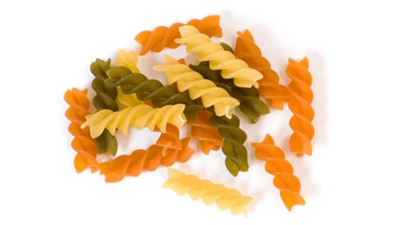

Recipe Reflection
Describe your product. Was the appearance and the flavour of the food satisfactory? Explain.
If the recipe is not to your liking how would you change it?
Will you make the recipe again? Why or why not?
List two things that you learned from this lab that you did not know before:
1.
2.

