MISO RAMEN
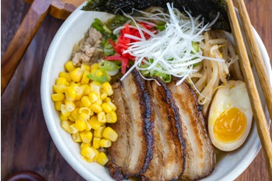
Serves 2/3
INGREDIENTS
- 2 cloves garlic
- 1 inch ginger
- 1 shallot
- 15ml white sesame seeds
- 15ml sesame oil
- ¼ lb ground pork
- 1ml Doubanjiang (spicy chili bean sauce/broad bean paste)
- 45ml miso
- 15ml sugar
- 800ml chicken stock/broth
- 2,5ml salt (kosher or sea salt)
- 1ml pepper
- 2 servings ramen noodles
Ramen Topping Suggestion:
- Spicy Bean Sprout
- Egg
- Corn kernels
- nori (seaweed)
- green onion/scallion (Chopped)
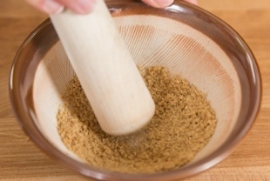
INSTRUCTIONS
- Gather all the ingredients.
- Mince the garlic, ginger, and shallot.
- Grind sesame seeds.

- In a medium pot, heat sesame oil over medium heat and cook the minced garlic, ginger, and shallot until fragrant.
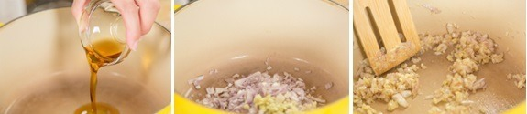
- Add the meat and increase heat to medium high. Cook the meat until no longer pink.

- Add spicy bean paste (La Doubanjiang) and miso.
- And add sesame seeds and sugar and mix well.
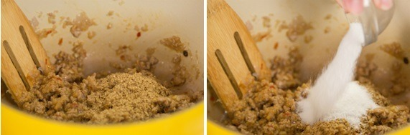
- Add chicken stock, salt and pepper.
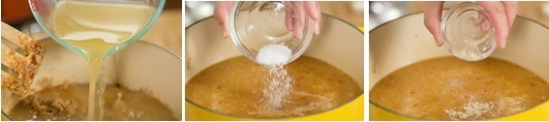
- Keep the ramen soup simmering.
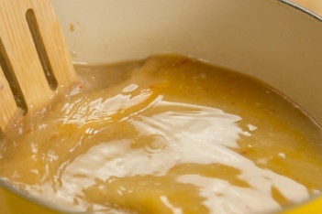
- Noodles will be done cooking in less than 2 minutes. Therefore, prepare ramen toppings first so you can serve the hot ramen immediately.

- Add ramen noodles to broth. Cook for 2 minutes.

How to Soft Boil Eggs
- Bring the water up to a boil, then lower it to a rapid simmer.
- Add the eggs to the pot, and then begin timing.
- If you're just cooking one or two eggs, five minutes is perfect for a runny yolk, or cook as long as seven minutes for a more firmly set yolk.

