**BUNELOS**

Fried Doughnuts – a popular snack in Mexico

Yield = 9 mini doughnuts

1 recipe / 2-3 people

**For whole unit:**

30 mL sugar

C:\Documents and Settings\mv12438\Local Settings\Temporary Internet Files\Content.IE5\24SYT6AL\MC900198665[1].wmf5-10 mL cinnamon

**Per recipe:**

125 mL all-purpose flour (plus additional)

1 mL salt

1 mL baking powder

5 mL sugar

½ egg (1 egg per unit for 2 recipes)

50 mL milk

7 mL margarine, melted

1. In a medium mixing bowl, stir together 30 mL sugar and the cinnamon. Set aside.
2. Sift flour, salt, baking powder and 5 mL sugar into a small mixing bowl.
3. In a medium bowl, whisk together the egg and milk.
4. Using a wooden spoon, gradually stir the dry ingredients into the wet ingredients then stir in melted margarine. Gradually add just enough extra flour to form soft dough that isn’t sticky.
5. 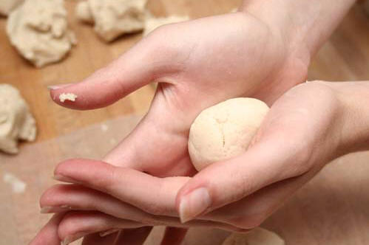Turn the dough out on to a lightly floured counter and knead (fold, press, turn…) until it is smooth and elastic.
6. Divide the dough in each recipe in to 9 equal-size pieces. Shape these pieces into balls.
7. With your hands, flatten the balls to disk shapes of about 2 cm (1”) thickness.
8. Use a **floured** handle of a wooden spoon to poke a hole through the centre of each

bunelo; spin the wooden spoon around quickly to create a doughnut shape.

1. Place bunelos in to the heated oil without over crowding the pan (overcrowding cools down the oil, causing the doughnuts to be “greasy”). Use tongs to turn them over when the first side is browned.

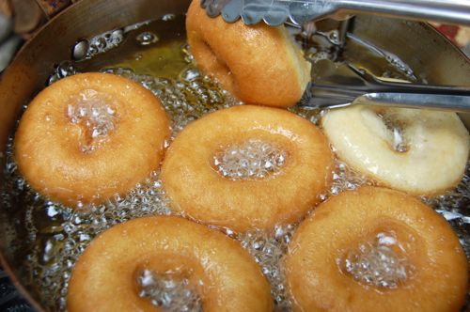

C:\Documents and Settings\mv12438\Local Settings\Temporary Internet Files\Content.IE5\LD32SZB6\MC900251485[1].wmf

1. When the bunelos are puffy and golden brown on both sides, remove them with tongs and

immediately place in the bowl of sugar/cinnamon, turning to coat on both sides.

Remove to a plate and serve warm.