Lava Cakes
Makes 4
Ingredients
125ml margarine
175ml chocolate chips
3 eggs
65ml sugar
Pinch if salt
7ml flour
4 large paper muffin cups

Method
- Preheat oven to 450°F
- Melt butter and chocolate in a double boiler. Remove from heat.
- In a medium bowl beat eggs, sugar and salt using an electric mixer until the sugar is fully dissolved
- Combine egg mixture with chocolate mixture until smooth.
- Beat flour until just combined
- Line muffin tins with muffin cups and spray PAM in the muffin liners.
- Divide batter among the muffin cups.
- Bake until batter puff but the center is not set 8-10 minutes.
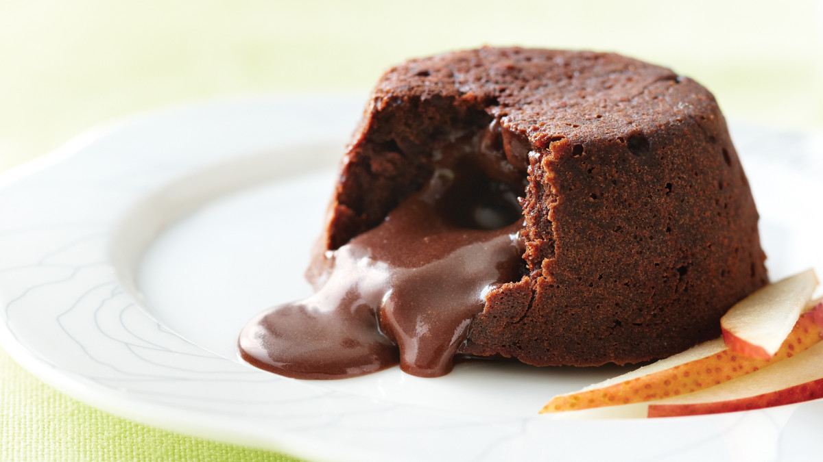
- Carefully lift cakes from the tin and set on a work surface. Pull paper away from cakes and transfer cakes to a plate.

