Samosas
In 2/3s
Ingredients

1 and a half potatoes
1 small onion, small diced
¼ bunch cilantro, chopped finely
60ml frozen vegetables
1 garlic cloves
1 inch of ginger
2 mL turmeric
5mL ground cumin
20 mL lemon juice
7 mL ground black pepper
2 mL salt

Method:
- Peel potatoes and chop into a large dice. Bring a medium pot of water to boil. Add potatoes, cook for 15 minutes or until they are ready to mash (easily put a fork through the potato). Drain water and mash the potatoes.
- Chop onion into a small dice. On medium heat, add10ml of oil in a pan. Add onion. Sauté for 1 minute.
- Add garlic and ginger to pan. Sauté for 1 minute.
- Add frozen vegetables to the pan.
- Stir and let it cook for approximately 2 minutes.
- Add salt, pepper, cumin and turmeric to the mixture. Stir and let it cook for approximately 5 minutes.
- Stir and let it sit for approximately 1 minute. Add finely chopped cilantro and add to the potato mixture.
- Put the mixture in a bowl and stick it in the freezer for 5 minutes.
- Fill mixture into the wrap. The instructions on how to fold samosas are below.
- Place samosas on baking tray with parchment paper, cover with wrap, label and place in fridge.

Pastry for Samosa
Ingredients:
250 mL all purpose flour
1 mL salt
5 mL lemon juice
125 mL water

Method:
- Combine flour, salt and lemon juice in a bowl.
- Add water, a little at a time until you have fairly firm dough. Knead well. Divide dough into 2 equal balls.
- Roll out ball into a rectangle about 0.3 cm thick. Meanwhile, placing the other under a damp cloth.
- Using a pizza cutter, cut 7cm thick strips. (4-5 short strips)
- Fold samosa according to diagram.
- Repeat steps 3-7 with the remaining dough.

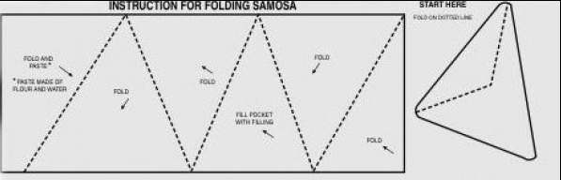

http://www.youtube.com/watch?v=kWjg3zdEx3w

