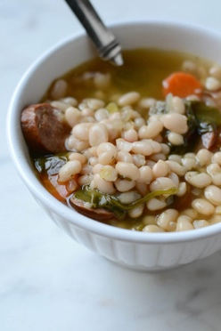
Kale, White Bean and Italian Sausage Soup
Serves 4-5
Ingredients:

2 Italian sausages
10ml olive oil
¼ onion, small diced
½ medium carrot, small diced
½ celery rib, small diced
2 garlic cloves, minced
1ml crushed red pepper flakes
1ml salt
1ml pepper
1000ml chicken broth
175ml white kidney beans
1 bunch kale, rinsed, stems removed, leaves torn into bite-sized pieces (approx. 4 cups firmly packed)
5ml lemon juice

Method:
- Remove the sausage from its casing and tear it by hand into bite-size pieces. Heat 5ml of the olive oil in a medium to large saucepan over medium heat. Add the sausage and cook, stirring occasionally, until lightly browned, about 5 minutes. With a slotted spoon, transfer the sausage to a plate, leaving any rendered fat in the pot.
- Add the remaining 5ml olive oil to the pot and add the onion. Cook, stirring frequently, until fragrant and beginning to soften, about 2 minutes. Add the carrot and celery and cook, stirring frequently, until they begin to soften and brown, about 2 minutes more. Stir in the garlic, pepper flakes, salt, and pepper and cook, stirring, until the garlic is fragrant, about 1 minute more.
- Add the chicken broth and bring to a boil over high heat.
- When the broth reaches a boil, reduce the heat to medium, add the sausage along with any collected juices, and half the beans. Mash the remaining beans with a fork or wooden spoon and add them to the pot, stirring to distribute.

- Stir in the kale, adjust the heat as necessary to maintain a gentle simmer, and simmer until the kale is tender, 15 to 20 minutes. Stir in the lemon juice and season to taste with salt and pepper, if necessary.

