Homemade Ravioli Day 2
Cooking Instructions:
- In a large pot, bring to boil a large quantity of salted water. Once water is boiling, add pasta, uncovered and cook up to 6 minutes (pasta is cooked when it floats to the top of the water).
- Remove pasta with a slotted spoon into colander. Drain well.
- Place a small amount of sauce on plate; add pasta and spoon on more sauce.
- Serve warm.

Tomato Sauce
Ingredients:
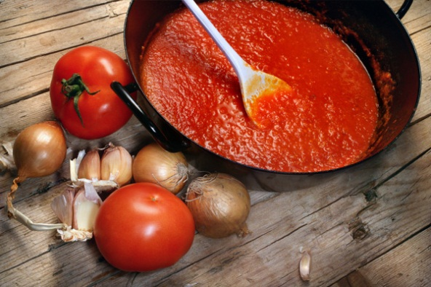
10 mL Oil
25 mL Onion, finely chopped
1 clove Garlic, minced
250 mL Tomato sauce
f.g. Oregano and basil
45 mL Parmesan cheese
10 mL Parsley, chopped
Method:
- Heat small pot on medium-high heat and sauté onion and garlic for until soft and clear.
- Add the tomato sauce and seasonings. Bring mixture to a low boil then simmer for ~15 minutes to incorporate the flavours.
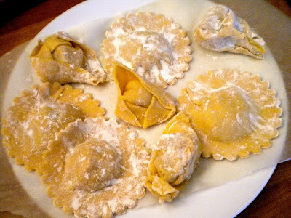
- Place a spoonful of sauce on plate (use back of spoon to spread it out on plate). Place cooked ravioli on the platter and top with remaining sauce. Sprinkle with Parmesan cheese and parsley. Serve immediately.

