Foods 11/12

HOMEMADE RAVIOLI
Cheese Filled or Meat Filled

Ingredients:
Dough: Cheese Filling:
325 mL Flour 125 mL Mozzarella Cheese, shredded
2 Eggs 50 mL Parmesan Cheese
30 mL Water 125 mL Ricotta Cheese
5 mL Salt 1 Egg
5 mL Oil ¼ Package, frozen spinach, drained

(1/2 Egg and 15 mL Water for sealing pasta dough)

Method:
Day 1:
Dough:
- In a large mixing bowl, sift flour and salt together.
- Make a “well” in the flour. Break eggs into the ”well”. Add water and oil. Beat the eggs with a fork. Gently work some flour from the side of the well into beaten eggs.
- Stir until mixture forms a ball.
- Knead vigorously until dough is smooth and elastic.
Cheese Filling:
- Combine first four (4) ingredients into a bowl.
- With your spinach, place it in paper towel, and squeeze out excess liquid, this step may need to be repeated. This is to ensure all excess liquid is removed (else your ravioli will be soggy).
- Add spinach to other ingredients, mix well.

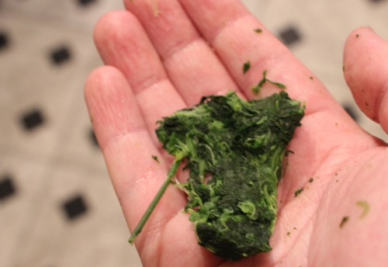
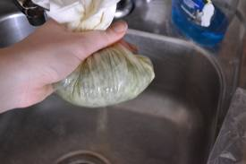

Meat Filling:
200g Ground Beef
1/8 Onion, chopped
1clove Garlic, chopped
f.geach Oregano, Basil, Salt and pepper
1mL Coriander
50mL Parmesan Cheese
Meat Method:
- Brown ground beef and drain off any excess fat if necessary. Add onion and garlic and cook until onion is translucent.
- Add oregano, basil, salt, pepper, coriander and cheese.
Make the Ravioli:
  - Set up pasta machine on unit table.
  - Roll dough out on pasta machine. It shouldn’t be any thinner than the second last setting. Trim ends to be square.
  - Place about 5 mL filling at 5 cm intervals along one edge of pasta strip.
  - Brush along edge of pasta with egg-water mixture, and then lift pasta over filling and seal edges of pasta around fillings, pressing well to close completely. It is important to remove excess air
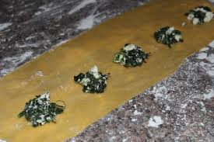
  - Using your dough scraper, cut between the mounds of filling. Make sure your ravioli are sealed; use a fork to press all edges. Place ravioli pieces on a parchment lined cookie sheet. Cover with a tea towel, label and refrigerate until next day.
