Name: Clean Up Job: Lab Date:
Pizza Day 1
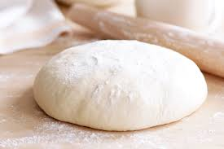
Ingredients
15ml dry yeast
185ml very warm water
375ml flour
5ml sugar
5ml salt

Method:
- Combine yeast, very warm water, sugar and salt into a small silver bowl.
- Stir all ingredients together and let sit for 5 minutes.
- In a large bowl, combine yeast mixture and flour.
- Knead for 4 minutes, until well blended. Adding more flour if necessary.
- Form dough into a ball. Put 5ml oil into a plastic bag and add the dough. Remove all air from the bag before tying a knot.

Pizza Day 2
Ingredients
125ml tomato sauce
2ml basil
2ml oregano
2ml garlic
125ml mozzarella

Method:
- Preheat oven to 425 F.
- Roll out the dough on the pizza sheet to desired thickness.
- Pinch up sides to form a crust.
- In a small bowl, mix tomato sauce and spices.
- Spread tomato sauce evenly on to pizza dough.
- Grate cheese and evenly spread on pizza.
- On the middle rack, bake pizza for 15-20 minutes or until crust is golden brown and cheese is bubbling.

