Fry Bread
Group of 2/3 Students
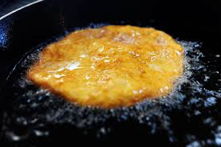
500ml flour
1ml salt
8ml baking powder
185ml warm water

Method:
- Combine flour, salt and baking powered in large bowl.
- Using a wooden spoon, stir in 185ml lukewarm water.
- Knead until soft and not sticky.
- Shape dough into balls about 3 inches in diameter.
- Flatten into patties, ½ inch thick and make small hold in the centre of each patty.
- Fry one at a time in hot oil, turning to brown on both sides.
- Drain on paper towels.

