How to Cook Rice
Serves 4/5 – Make 1 per group
Parboiled Rice

250ml rice
500ml cold water
2ml salt
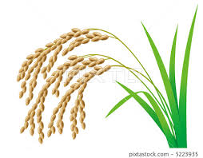

- Measure all three ingredients into a medium pot that has a tight fitting lid.
- Put lid on pot and turn heat to high.
- When water boils, lift the lid and give the rice a quick stir with a fork.
- Replace the lid. Lower heat to the lowest setting on the stove.
- Set timer for 20 minutes. DO NOT PEEK DURING THIS TIME!
- After 20 minutes, you should see ‘fish eyes’ on the surface of the rice and the kernels should have absorbed all the water.
- Lightly, with a fork, lift the rice a few times to fluff it up.

Easy Fried Rice
Serves 2/3
Ingredients
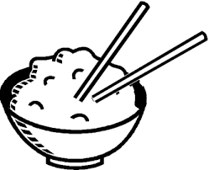
20 ml oil
1 egg
¼ onion, finely chopped
1 clove garlic, minced
½ carrot diced
125ml frozen corn
125ml frozen peas
1 green onion cut very thinly
30 ml soy sauce
Method:
- Heat 5ml oil in wok or large skillet over medium heat. Add egg and scramble. Once cooked, remove egg and place in small bowl.
- Add 15ml oil to wok/large skillet. Add minced garlic and finely chopped onions. Sauté until onions are tender, but not yet brown.
- Add diced carrot. Sauté for 2-3 minutes.
- Thaw frozen peas and carrots in a sifter by running under hot tap water. Add to wok. Sauté until all vegetables are warm, approximately 3-5 minutes.
- Add thinly slice green onions, egg, rice and soy sauce.
- Cook and stir until mixture is well blended.

