Ms. REID  mreid@sd44.ca  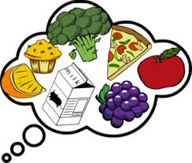 | Food Studies 9  Name:_____________________  Date:_________  Period:____  Students are expected to be able to do the following:  - Understand context: conduct research on food preparation, food born illness, ethical issues related to food systems, First People’s traditional food use and health, economic and environmental factors that influence food availability  - Defining & Ideating: generate creative ideas in choosing a design opportunity in regards to food  - Prototyping: find sources of inspiration and develop a plan for creating meals  - Testing: make desired changes to the plan (prototype) and troubleshoot  - Making: use the appropriate tools to create food  - Reflecting: on design thinking and processes and evaluate own ability to work effectively and gather continual feedback from peers  - Demonstrate precautionary and emergency safety procedures in the Foods room  Classroom Expectations  Behavior- all students are expected to show courtesy, and respect for each other and towards the teacher  Safety- with no exception, all students are expected to follow safety rules when using the equipment in the kitchens and Foods room  Attendance- expected for each class, if there is an absence a note is required before the student can make up any missed work  Evaluation  Theory (understanding, defining, & ideating):  - Safety and Equipment Quiz - Digital Recipe Box & Reflections  - Assignments/ Worksheets - Personal & Social Responsibility  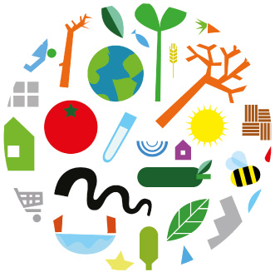  Practical (prototyping, testing, making, & sharing):  - Follow rules of safety and sanitation - Read and follow recipe instructions accurately  - Work cooperatively in groups - Creativity

Lab Evaluation Rubric

 | Meeting Expectations | Approaching Expectations | Not Yet Meeting Expectations
Preparation | All group members worked to prepare for the lab. Aprons were put on, hands washed, hair tied back, recipes out without reminders. Everyone helped to get the ingredients and equipment ready for use. Student has a container to take home food. | Group members were mostly ready, may have needed reminder for washing hands, apron on, tying hair back and getting organized for lab. Student has a container to take home food. | Group members did not wash their hands and/or tie their hair back and/or need prompting to put on an apron. All group members did not participate in getting of ingredients or equipment. Student does not have a container to take home food.
Safety and Sanitation | Student demonstrated correct use of all kitchen equipment. Lab is carried out with full attention to all safety and sanitation procedures. | Student needed a reminder about safety and sanitation practices. | Student needed several reminders about safety and sanitation practices.
Teamwork | Students worked effectively together as a team, were willing to complete all tasks. Worked steadily throughout the lab. Were positive and helpful to one another. | Students completed the tasks, but complained, needed occasional prodding or were at times off task. | Students did not work as a team. Work was divided unfairly or some members did not do their share. Group members off task. Many reminders needed to be on task, did not show a willingness to participate.
Applied Skills and Techniques | Students paid attention to recipe detail. Students focused on using skills taught. Students were able to complete recipe with little teacher assistance. Critical thinking and independent problem solving are displayed | Selective recipe reading and/or simple mistakes made. Students not focused on using skills taught. | Did not read recipe, several mistakes and/or no attempt made to use skills taught.
Time Management | Lab was set up and completed on time. | Lab was completed on time with some reminders. | Teacher had to step in to finish lab on time and/or lab did not finish on time.
Final Product | Final product turned out as expected, students put effort into plating. Took proper measures to check for ‘doneness’  Product was completed on time. | Product is similar to product standards. Product was completed on time. Product was completed on time. | Final product did not turnout, and/or students did not show the product for marking. Product was not completed on time.
Clean Up | All equipment cleaned, dried, and put away properly in units. Towels & cloths remain in the unit until a final unit check is completed.  Students cleaned up as they went through the lab. All clean up duties were completed without reminders. | Students cleaned as they went through the lab. Needed a reminder for a cleaning task. | Students left all cleaning for the end of the lab, cleaning was incomplete and students needed several reminders about tasks to complete.

Class Website: www.seycovefoods.weebly.com

It is expected that you check the class website often. It should be the first place to look for makeup work if a class is missed

Digital Recipe Box

Every student will be creating a Digital Recipe Box using Google Drive. After each lab, I will be posting the recipe on our class website under Foods 10. You are expected to download the recipe from the website and upload the recipe into your Digital Recipe Box. Each term a deadline will be set and I will evaluate your Digital Recipe Box.

Lab Reflections - After labs, I will be posting a link to a recipe reflection on the class website. Students are expected to complete lab reflections and they will be assessed.

Resource Materials to be supplied by the student:

- 3 Ring Binder
- Pen/Pencil/Paper
- Hair elastics if needed

