CALZONE

Recipe makes 2-3 individual size

This recipe could also be used to make appetizer (bite-sized) Calzone. They can be made ahead and frozen, then baked from frozen on a greased sheet pan at 425ºF (220ºC) for about 15 minutes, or until golden brown.

DAY 1: PREPARE DOUGH AND TOMATO MEAT SAUCE

Dough:

A: 7.5 mL sugar B: 185 mL flour
25 mL very warm water 1 mL salt
5 mL active dry yeast 15 mL olive oil
40 mL very warm water

- Combine all of the “A” ingredients in a 250 mL size liquid measure. Cover the measure with a folded paper towel to keep in the warmth. Allow the mixture to rest for about 10 minutes. When it is ready, you should see thick foam on top.
- Combine all the “B” ingredients in a large mixing bowl. Add foamy yeast mixture and mix well. You may need to add more flour (up to 50 or 100 mL) to form soft dough that is neither too sticky nor too dry. Dough should feel about the same as pressing your finger into your cheek when your face is relaxed.
- Turn the dough out on to a clean and dry counter. Knead the dough until it is smooth and elastic (about 10 minutes). Sprinkle a bit of flour on the counter only if the dough is sticking to the counter. Avoid adding too much flour and making the dough dry and hard.
- Place dough in a labelled and lightly greased (a few mL of oil rubbed around the inside) plastic bag.

Tomato Sauce:

15 mL vegetable oil ¼ green pepper
¼ onion, chopped 125ml mL tomato sauce
2 cloves garlic, minced salt and pepper to taste
3 small mushrooms, chopped 1-2 mL each of dried basil & oregano leaves

- Place oil in a frying pan and pre-heat for 1-2 minutes on just below medium heat
- Add onions, garlic, green peppers and raw mushrooms and sauté until softened and onions are translucent.
- Add tomato sauce and seasonings.
- Heat mixture just to boiling, then reduce heat and simmer (just bubbling gently) for about 5-10 minutes to blend flavours and reduce sauce. Simmer until sauce is very thick.
- Remove from heat and allow sauce to cool before transferring to labelled, covered storage containers.
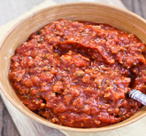

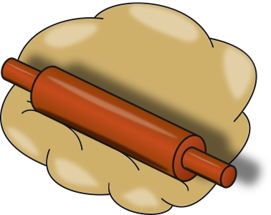
CALZONE

DAY 2: SHAPE, FILL, BAKE & EAT!

- Preheat oven to 425ºF (220ºC) and place parchment paper on baking tray.

- Prepare fillings as necessary (grate cheese, prepare pepperoni).
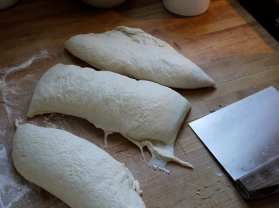
- Remove dough from bag and knead about 10 times to remove any remaining large air bubbles. Ensure that the dough is not sticking to the counter. If it is sticking, knead in a bit more flour until it no longer sticks, but not so much that the dough becomes dry/hard. Gather up the dough and divide into equal portions for the number of calzone your group is making. Each student should shape and fill their own calzone, if making individual size.

- Lightly sprinkle the counter with about 5 mL cornmeal for each piece of dough. Roll out each calzone into a thin circle, about 10”/25cm for dough divided in half, or about 7-8”/15-20cm if making 4-5 calzone (luncheon-plate size).

- Divide sauce into equal portions for each calzone. Spread each portion of sauce over only half of one dough circle, leaving the edges clean for sealing/rolling. Top sauce with optional fillings, again spread over only the same half of the dough circle.

- Moisten outside edges of each circle with a bit of water. Fold unfilled dough over fillings. Press top of crust over fillings to exclude as much air as possible and press edges to seal. Roll edges slightly to form a neat edge crust. Brush the top with a bit of olive oil.

- Place calzone on the greased pan and bake for 12-15 minutes or until the crust is golden brown and fillings are heated through.

