Cranberry-Lemon Scones
Yield; 8 scones

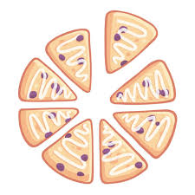
Ingredients
300 ml Flour
50 ml Sugar
7 ml Baking Powder
1 ml Baking Soda
1 ml Salt
60 ml Cold Butter or Margarine
1/2 Lemon, Zested
175 ml Fresh or dried cranberries
1 egg
75 ml Buttermilk

Method
- Preheat oven to 400’F
- In a large bowl, combine flour, sugar, baking powder, baking soda, and salt.
- Cut in butter until mixture resembles small peas.
- Gently mix in lemon zest and cranberries.
- In a small bowl, combine egg and buttermilk. Gradually add to dry mixture, mixing until a dough forms.
- Turn onto a lightly floured board and knead 5-7 times.
- Pat into a circle that is 1 ½ ( 3.75 cm) thick.
- Cut into 8 wedges.
- Place on lightly greased baking sheet and bake for 12-15 minutes, or until golden brown.
Let cool on cooling rack.

