Corn and Red Pepper Chowder

Serves 2-3
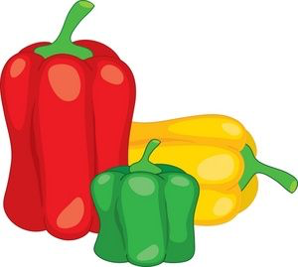
Ingredients:
- 5ml butter
- 1/2 celery stalk, finely chopped
- 1 garlic clove, minced
- 1/4 onion, finely chopped
- 1/2 red pepper, diced
- 1ml salt
- 1ml ground pepper
- 125ml reduced sodium vegetable or chicken broth
- 125 ml water
- 1 red potato, cut into 1cm cubes
- 180ml frozen corn kernels
- 10ml flour
- 100ml milk or cream
- Optional: more salt pepper or other spices of choice!

Method:
- Prepare ingredients as listed.
- In a large pot, melt margarine over medium heat.
- Sauté celery, garlic, onions, red pepper, salt ad pepper for about five minutes or until onions are softened (but not browned.)
- Stir broth, potatoes, corn and water. Bring to boil over high heat.
- Reduce heat to low, cover and simmer for 10 minutes, or until potatoes are almost tender.
- Increase heat to medium. Whisk flour into milk and gradually stir into pot.
- Simmer, uncovered, stirring often, for about 5 minutes or until slightly thickened (do not let boil)
- Season to taste with salt and pepper and others
- Ladle into bowls and serve hot!

