Chimichangas
Ingredients
350g ground beef
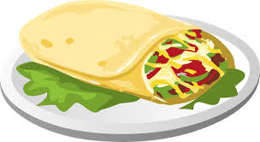
¼ chopped onion
2ml garlic powder
2ml salt
1ml cayenne pepper
175ml refried beans
80ml salsa
125ml cheddar cheese, grated
60ml green chilies
5 corn tortillas
30 ml margarine
Method
- Preheat oven to 450 F
- In skillet, brown beef. Add onion, garlic powder, salt and cayenne. Fry until onion is transparent. Drain fat.
- Stir in refried beans, salsa, cheeses and green chillies.
- Heat tortillas on baking sheet in oven for 2 minutes.
- Spoon about 125ml meat mixture onto the centre of each tortilla. Fold opposite sides over filling and fold ends in.
- Place seam side down on a lightly greased 8 by 8 pan. Brush with melted margarine.
- Bake for 12 minutes until golden brown.
- Suggestion – Top with additional salsa, sour cream and chopped cilantro

What’s the difference between a burrito and a chimichanga?
A burrito is a delightfully stuffed flour tortilla, filled with your choice of meat, vegetables and spices. The main difference between a burrito and a chimichanga lies in the final step – deep-frying. When you drop the artfully wrapped and stuffed tortilla into the deep-fryer, it becomes a chimichanga!

