Chicken Teriyaki Udon
- Yield - 4
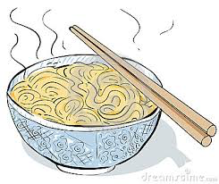
Ingredients:
Sauce:
35 ml brown sugar- packed
8 ml sesame oil
35 ml rice vinegar
8 ml cornstarch
35 ml water
1 clove minced garlic
35 ml soy sauce
5 ml minced ginger root

Chicken-Vegetable mixture:
2 chicken breasts -- skinless, boneless and cubed
25 ml cornstarch
125 ml red peppers - sliced thin
125 ml yellow peppers - sliced thin
5 ml sesame seeds
35 ml fresh coriander or parsley - chopped (for garnish)

Method:
- Make the sauce, in a bowl, whisk together all the sauce ingredients until smooth. Set aside.
- Dust the cubed chicken with cornstarch. In a wok or large non-stick skillet, add 15ml of oil, cook the chicken 3 minutes over medium high heat or until browned.
- Add the peppers, sesame seeds and cook 3 minutes more until the chicken is cooked through and the vegetables are tender and crisp.
- Add the sauce and cook 2 minutes or until thickened and bubbly.
- Serve over the udon noodles. Garnish with chopped coriander or parsley.

Udon Noodles
- Bring a pot of water to a boil. Add 5 ml of oil.
- Add udon noodles once water is boiling. Cook for 2 minutes.
- Strain noodles and plate.

