Cheese and Broccoli Soup
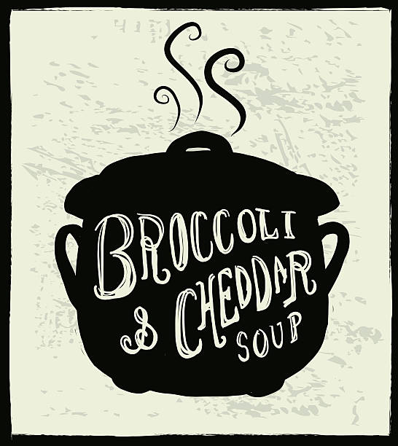
Ingredients:
½ onion chopped finely

25ml butter
25ml flour
250ml milk

250ml chopped frozen broccoli (small pieces)
250ml chicken stock
125ml cheddar (grated)
Salt and pepper to taste

Directions:
- Over medium heat, in a small pan, sauté until onion are soft and translucent (4min or so). Then turn the heat off.
- In a small pot, melt butter on medium low heat.
- Add flour to melted butter a bit at a time. Mix really well with a whisk to prevent lumps.
- Cook flour and butter mixture for about 2 minutes - stirring constantly. Remove from heat.
- Slowly add milk to flour and butter, mixing thoroughly with the whisk as you go to remove lumps.
- When all the milk is added, return it to the heat, and gently warm it up.
- When the milk, butter and flour mixture (this is a white sauce) is hot, begin to add the cheese a bit at a time. Allow it to melt in before adding more.
- Combine onion, chicken stock and broccoli in a medium pot. Turn up to medium heat for 5 minutes or until warm.
- Slowly add the cheese sauce to the soup, mixing thoroughly as you do so to avoid lumps.
- Add pepper and salt to taste.
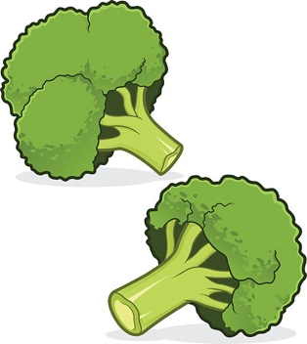
- Enjoy!

