Butternut Squash Soup with Apple & Bacon
One recipe per unit of 2-3 people
(Yield is about 500 mL)

Smoky bacon, herby sage, and sweet apple give this squash soup layers of flavor.

2 slices bacon, cut crosswise into 1-cm (¼-inch) strips
400g butternut squash (1/4 medium), peeled, seeded, and cut into 1 cm / ½ -inch dice (about 2 cups)
1/4 small Granny Smith or other tart-sweet apple, peeled, cored, and cut into ½ -inch dice (about 1/2 cup)
5 mL finely chopped fresh sage leaves
1 mL kosher salt
1 mL (¼ tsp.) freshly ground black pepper
350mL homemade or low-salt chicken or vegetable broth

- In a large saucepan set over medium-low heat (#3 - 3.5?), cook the bacon, stirring occasionally, until crisp and golden, 8 to 10 minutes. Use a slotted spoon to transfer the bacon to a plate lined with paper towels.
- Increase heat to medium. Add the diced squash to the pot with the bacon fat and cook until lightly browned, 4 to 6 minutes (resist the urge to stir it too often or it won’t brown). Stir in the diced apple, finely chopped sage, salt, and pepper and cook for about 4 minutes (you’ll see more browning occur on the bottom of the pot than on the vegetables, but don’t let it turn black). Add the broth, scraping up any browned bits in the pot with a wooden spoon. Bring to a boil over high heat, then immediately reduce the heat to maintain a simmer, and cook until the squash and apples are very soft, 6 to 8 minutes. Undercooked squash &/or apple will not purée easily. Remove from the heat and let cool somewhat.
- Add about half the bacon to the soup and purée, using a stand blender (you’ll need to work in batches) Taste and add more salt and pepper if needed. Reheat the soup and garnish each serving with the remaining bacon.
Nutrition information (per serving):
Size : based 3.5 servings; Calories (kcal): 130; Fat (g): fat g 4; Fat Calories (kcal): 35; Saturated Fat (g): sat fat g 1.5; Protein (g): protein g 7; Monounsaturated Fat (g): 1.5; Carbohydrates (g): carbs g 19; Polyunsaturated Fat (g): 0.5; Sodium (mg): sodium mg 370; Cholesterol (mg): cholesterol mg 10; Fiber (g): fiber g 4
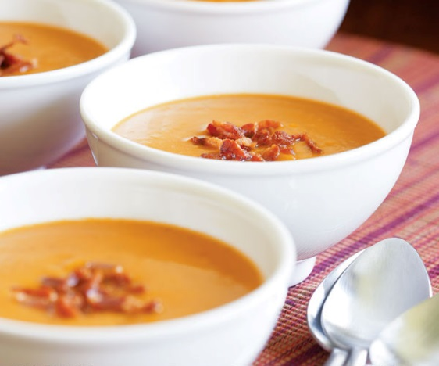

Adapted from a recipe at http://www.finecooking.com/recipes/butternut-squash-soup-apple-bacon.aspx Foods 11-12(B) Vint 2016

