Indian Butter Chicken
Serves 2/3

Ingredients

1 chicken breast chopped into small cubes
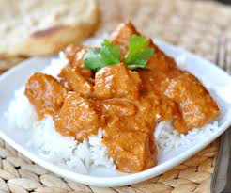
7ml vegetable oil
7ml curry powder

15ml butter
¼ onion chopped very, very small
1 garlic clove chopped very small
60ml tomato sauce
60ml whipping cream
60ml milk
1 ml salt
2ml sugar
2 ml cayenne pepper
2ml garam masala powder

Directions:

- In a bowl, mix together the cut up chicken and curry powder.
- In a large frying pan, heat 15ml of vegetable oil over medium heat.
- When the oil is hot (but not smoking!) add the cubed chicken breast and cook over medium heat for 6mins stirring so it doesn’t burn. Then remove from heat and put chicken in a bowl to “rest”.
- In the same frying pan, melt 15ml of butter over medium heat. Stir in onion and garlic and cook slowly until the onion caramelizes to a dark brown, about 15 minutes.
- Add to the frying pan with onions the remaining butter, tomato sauce, whipping cream, milk, salt, sugar cane, pepper, and Garman masala powder. Bring this to a simmer, and then reduce heat to medium-low, cover, and simmer for 10 minutes, stirring occasionally.
- Add the cooked chicken to the sauce and serve over rice.

Quick Naan Without Yeast
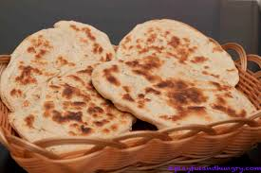
Ingredients
200ml flour
5ml sugar
2ml salt
3ml baking powder
5ml oil
60ml milk
Method:
- Combine all dry ingredients in a large bowl.
- Create a well in the middle of the dry ingredients, and add the oil and milk.
- Mix everything together until it forms a ball. Knead until very smooth and elastic – at least 5 minutes – adding more flour or milk as necessary.
- Let the dough rest for 10 minutes.
- Divide the dough into four.
- Head a skillet over medium-high heat.
- Roll one piece of dough until very thin (~4mm thick).
- One at a time, cook the naan for about 90 seconds, or until parts are blackening on each side.

