Breakfast Cookie
Groups of 2-3
Ingredients:
125 mL brown sugar
185 mL quick oats
250 mL whole wheat flour
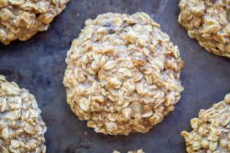
2 mL baking soda
5 mL baking powder
1 mL ground ginger
½ mL ground cloves
30 mL ground flax
30 mL rice krispies
30 mL wheat germ
30 mL canola oil
40 mL apple sauce
15 mL water
1 egg
3 mL vanilla extract
60 mL raisins or cranberries (optional)
Directions:
- Preheat oven to 350 F
- In a large bowl mix together brown sugar, oats, flour, baking soda, baking powder, ginger, cloves, flax, rice krispies and wheat germ.
- Make a well in the centre and add canola oil, apple sauce, water, eggs and vanilla. Mix until well blended.
- Stir in raisins/cranberries.
- Scoop out golf ball sized cookies onto cookie sheets. Flatten with the back of a spoon. These cookies do not spread when baked.
- Bake 8 to 10 minutes in preheated oven.
- Let cool on pan for 2 minutes before transferring to a cooling rack.

