FOODS 9
Breakfast Burrito (with Bacon)
Serves 2
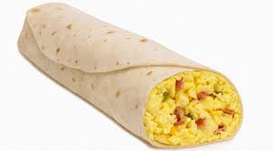
Ingredients
3 eggs
20ml water
½ tomato, cut into strips
50ml green onions, chopped
125ml cheddar cheese, grated
2 slices of bacon, cooked and crumbled
2 large flour tortillas
60ml salsa
Method:
- Over medium heat, cook bacon in a pan until crisp.
- Place on a paper towel, crumble and set aside.
- In a medium bowl, beat eggs and water with a fork.
- Over medium heat, pour egg mixture and immediately reduce heat to medium low.
- As mixture begins to set, gently move spatula across bottom and sides of skillet to form large, soft curds.
- Cook until eggs are thickened and no visible liquid egg remains, but they are still moist (4-5 minutes).
- On a cutting board, cut tomatoes into strips and dice green onions.
- Grade cheese and place in small bowl.
- Heat tortillas in microwave on a plate for approximately 10 seconds.
- Spread tomatoes, green onions, bacon and cheese over tortilla. Add scrambled egg and top with salsa. Roll tortilla up into a burrito.

