Name: Date:
Banana Pancakes
Ingredients
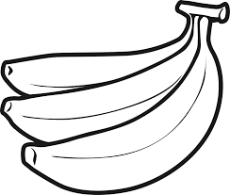
125ml all-purpose flour
10ml white sugar
5ml baking powder
2ml salt

½ egg
125ml milk
15ml vegetable oil
1 ripe banana, mashed
Method:
- Combine flour, sugar, baking powder and salt.
- On a plate, with a fork, mash the banana until there are no large lumps.
- In a separate bowl, mix together ½ egg, milk, vegetable oil and banana.
- Stir flour mixture into banana/liquid mixture; batter will be slightly lumpy.
- Heat a buttered frying pan over medium heat. Pour or scoop the batter onto the frying pan, using approximately 60ml cup for each pancake.
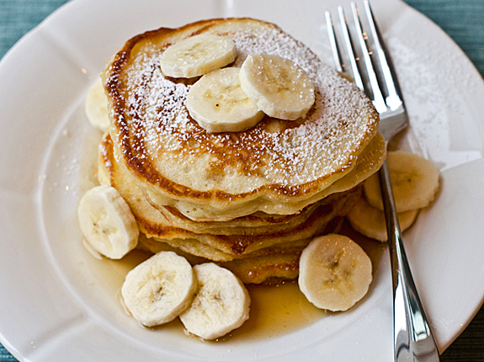
- Cook until pancakes are golden brown on both sides. Serve hot.

Recipe Reflection
What would you add/remove to this pancake recipe to make it suit your tastes?
If the recipe is not to your liking how would you change it?
Will you make the recipe again? Why or why not?
List two things that you learned from this lab that you did not know before:
1.
2.
Bananas are added to this pancake recipe to make it healthier. Think of three substitutions or food to add to a traditional breakfast recipe to make it healthier.
1.
2.
3.

