Apple Galette
Cooking Principle-Pastry
Groups of 2/3 Students

Day 1:
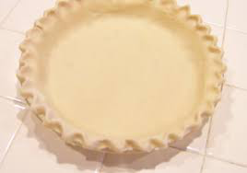
Pastry:
250ml flour
2ml salt
50ml shortening
50ml margarine
½ egg
7ml vinegar
15ml cold water

Method:

- Combine flour and salt in mixing bowl.
- Cut in shortening and margarine into flour with pastry blender until mixture is uniform and resembles coarse crumbs.
- Stir the water, egg and lemon juice together in a small bowl. In a circular motion pour contents onto flour mixture.
- Stir with a fork until the mixture is moistened. Make sure not to over mix to prevent making a tough crust.
- Place in plastic bag with name on it and put in fridge.

Day2:
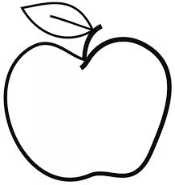
Filling:

1 and ½ apples
5ml cornstarch
2ml cinnamon
25ml sugar
5ml lemon juice

Method:

- Preheat the oven to 400F
- Roll pastry dough into an oval using a rolling pin, 1cm thick Place on parchment paper on cookie sheet.
- Wash apples and slice into thin pieces.
- In a separate bowl, mix cornstarch, cinnamon, sugar and lemon juice together
- Toss apples into mixture until they are coated.
- Place in the centre of the rolled out pasty and fold edges of pastry to create a pocket
- Wish a brush, spread egg and milk mixture over the edges of the crust to provide a shiny glaze.
- Place in oven and bake for 20-25 minutes.
- When apple galette is done, sprinkle with a dusting of icing sugar.

