Alfredo Sauce
Serves2-3

Ingredients
15 mL butter
200 mL 2% milk
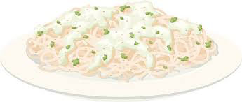
15ml mL flour
40 mL parmesan cheese
2.5 cloves garlic
1 mL dried basil
30 mL low fat sour cream
1 mL salt, 1 mL pepper
80mL frozen peas, thawed
15 mL chopped fresh parsley

Method
- Melt the butter in a medium saucepan over medium heat. Add the garlic and sauté for 1 minute.
- Mix the milk and flour together until smooth. Add to garlic.
- Increase heat to medium-high. Cook and stir until mixture is bubbly and thickened, about 4-5 minutes.
- Reduce heat to low.
- Stir in parmesan cheese, basil salt and pepper. Cook for 1-2 minutes.
- Stir in sour cream and peas. Cook until heated through, about 2 minutes.
- Pour sauce over fettuccine and toss to coat. Sprinkle parsley over top.

