Nanaimo Bars
In groups

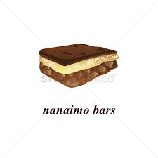
Bottom Layer Ingredients:
125ml unsalted butter or margarine
65ml white sugar
75ml cocoa
5ml vanilla
1 egg (lightly beaten)
500ml graham cracker crumbs
250ml shredded coconut
125ml chopped walnuts

Bottom Layer Method:
- In double boiler melt butter
- Add sugar, cocoa, vanilla and egg, stirring constantly until mixed
- Combine crumbs, walnuts and coconut with mixture; mix well.
- Press into square pan 8”x8”; place in refrigerator to set.

Filling Ingredients:
65ml butter
30ml milk
30ml custard powder
500ml icing sugar

Filling Method:
- Using an electric beater, cream the butter until light and fluffy
- Gradually work in the icing sugar and custard powder, alternating with the milk and beating well after each addition.
- Spread evenly over bottom layer and refrigerate until hardened.

Glaze Ingredients:
125ml chocolate chips
30ml butter

Glaze Method:
- Melt chocolate and butter in top of a double boiler; stir.
- Spread evenly and very thinly over filling; do this quickly so mixture does not harden.
- Score while still soft.
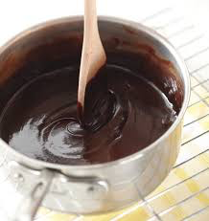
- To serve, cut in small squares.

